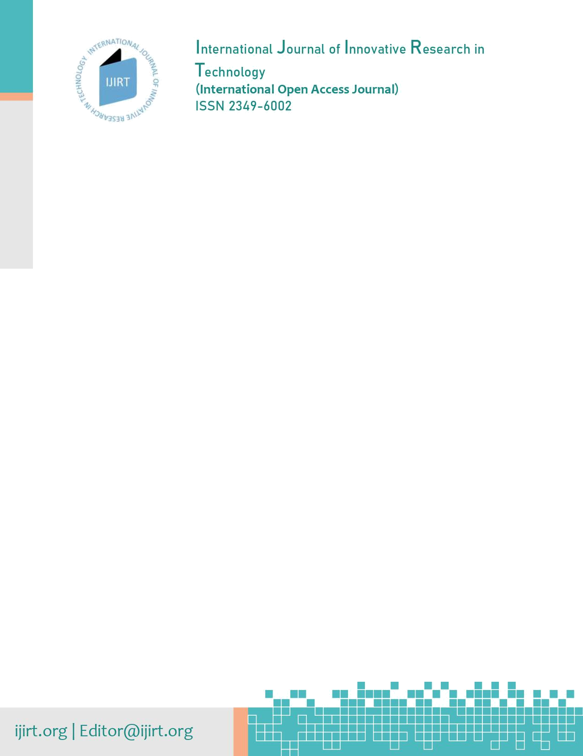

COPYRIGHT TRANSFER AGREEMENT FORM

The undersigned hereby transfer any and all rights in and to the paper including without limitation all copyrights to the IJIRT.

Paper ID : 155039

Article Title : Augmentation Techniques Analysis with removal of Class Imbalance using PyTorch for Intel Scene Dataset

The IJIRT and Authors hereby agree as follows:

In consideration of IJIRT reviewing and editing the above described work for first publication on an exclusive basis: The undersigned author(s) hereby assigns, conveys, and otherwise transfers all rights, title, interest, and copyright ownership of said work for publication.

Work includes the material submitted for publication and any other related material submitted to IJIRT. In the event that IJIRT does not publish said work, the author(s) will be so notified and all rights assigned hereunder will revert to the author(s). The assignment of rights to IJIRT includes but is not expressly limited to rights to edit, publish, reproduce, distribute copies, include in indexes or search databases in print, electronic, or other media, whether or not in use at the time of execution of this agreement, and claim copyright in said work throughout the world for the full duration of the copyright and any renewals or extensions thereof. All accepted works become the property of IJIRT and may not be published elsewhere without prior written permission from IJIRT. The author(s) hereby represents and warrants that they are sole author(s) of the work, that all authors have participated in and agree with the content and conclusions of the work, that the work is original, and does not infringe upon any copyright, propriety, or personal right of any third party, and that no part of it nor any work based on substantially similar data has been submitted to another publication. However, reproduction, posting, transmission or other distribution or use of the article or any material contained therein, in any medium as permitted hereunder, requires a citation to the Journal and appropriate credit to IJIRT as publisher, suitable in form and content as follows: Title of article, author(s), journal title and volume/issue, Copyright, After payment no withdraw or refund of paper. © Current year.

As the corresponding author, I also warrant that IJIRT and the Journal Editors will not be held liable against all copyright claims of any third party or in lawsuits that may be filed in the future, and that I will be the only person who will be liable in such cases. I also warrant that the article contains no libelous or unlawful statements, I/we did not use any unlawful method or material during the research, I/we obtained all legal permissions pertaining to the research, and I/we adhered to ethical principles during the research.

NOTE: if all auhtor are not available than sign this form with only 1(Single) author. 1(Single) author sign is enough for this form, Sign and send scanned copy to editor@IJIRT.org

Sr.# | Author | Signature
1 | Anusha Kanukolanu | 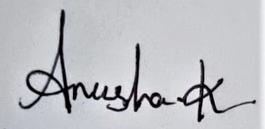
2 | Dr. S Phani Kumar
3 | Allena Venkata Sai Abhishek

DATE : 2 1 | 0 5 |2 0 2 2 (DD|MM|YYYY) Place : Hyderabad

Powered by TCPDF (www.tcpdf.org)

